CO-2
ASSESSMENT TOOL 1
INTEGRATED EXPERIMENTS
NAME: Y.SAI PRASANTH VARMA REGISTRATION NUMBER:192411191
COURSE NAME: INTERNET PROGRAMMING
COURSE CODE: CSA4308

QUESTIONS:
Experiment 1: Responsive Layout Design
Suppose that a retail website is not responsive across mobile and tablet devices, causing
misalignment of content and improper spacing.
Source Code:
<!DOCTYPE html>
<html>
<head>
<title>Responsive Layout</title>
<style>
*{
margin:0;
padding:0;
box-sizing:border-box;
}
body{
font-family:Arial;
}

header,nav,footer{
background:#333;
color:white;
text-align:center;
padding:15px;

.container{
display:flex;
gap:10px;
padding:10px;
}
.content{
flex:3;
background:#f2f2f2;
padding:20px;
}
.sidebar{
flex:1;
background:#ddd;
padding:20px;
}
footer{
margin-top:10px;
}
@media(max-width:768px){
.container{
flex-direction:column;
}
}
</style>
</head>
<body>
<header>
<h2>Retail Website</h2>
</header>
<nav>
Home | Products | Offers | Contact
</nav>
<div class="container">
<div class="content">
<h3>Main Content</h3>
<p>Product details and offers.</p>
</div>
<div class="sidebar">
<h3>Sidebar</h3>
<p>Categories & Ads</p>
</div>
</div>
<footer>
Copyright © 2026
</footer>
</body>
</html>

Output:
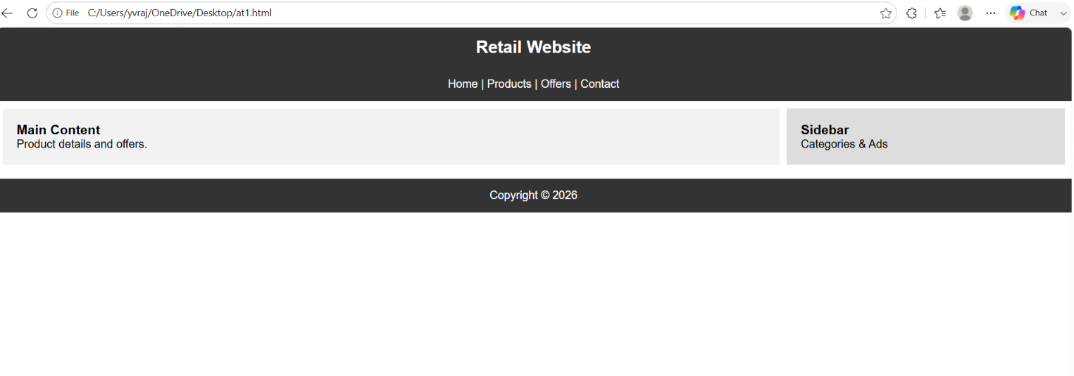
(a) Analyze the possible reasons for lack of responsiveness in the existing layout.
- Fixed-width layouts
- No media queries
- Large images without scaling
- Improper spacing and alignment
- No Flexbox or CSS Grid
(b) Design a responsive webpage layout using CSS Flexbox or Grid, ensuring proper
alignment of header, navigation, content, and footer.
- Used CSS Flexbox for layout.
- Includes Header, Navigation, Content, Sidebar, and Footer.
(c) Demonstrate how the layout adapts to different screen sizes (mobile, tablet, desktop)
using media queries.
- Desktop: Content and sidebar displayed side by side.
- Mobile/Tablet (≤768px): Content and sidebar stack vertically.
(d) Implement spacing, alignment, and distribution techniques to improve visual consistency.
- Used padding, margin, gap, and flex properties.
- Elements are evenly aligned with proper spacing.
(e) Evaluate the effectiveness of the responsive design and suggest further improvements.
- Responsive on mobile, tablet, and desktop.
- Better readability and user experience.
- Further improvements:
  - Use CSS Grid for more complex layouts.
  - Add responsive images.
  - Include a hamburger menu for mobile navigation.
  - Use Bootstrap or Tailwind CSS for faster responsive development.
Experiment 2: Form Validation using JavaScript
Suppose that a registration form accepts invalid email and phone number inputs, leading to
incorrect data submission.
Source Code:
<!DOCTYPE html>
<html>
<head>
<title>Form Validation</title>
<script>
function validateForm() {
let email = document.getElementById("email").value;
let phone = document.getElementById("phone").value;
let emailPattern = /^[^\s@]+@[^\s@]+\.[^\s@]+$/;
let phonePattern = /^[0-9]{10}$/;
document.getElementById("emailError").innerHTML = "";
document.getElementById("phoneError").innerHTML = "";
let valid = true;
if (!emailPattern.test(email)) {
document.getElementById("emailError").innerHTML = "Invalid Email";
valid = false;
}
if (!phonePattern.test(phone)) {
document.getElementById("phoneError").innerHTML = "Enter 10-digit Phone Number";
valid = false;
}
return valid;
}
</script>
</head>
<body>
<h2>Registration Form</h2>
<form onsubmit="return validateForm()">
Email:
<input type="email" id="email" required>
<span id="emailError" style="color:red"></span>
<br><br>
Phone:
<input type="text" id="phone" required>
<span id="phoneError" style="color:red"></span>
<br><br>
<input type="submit" value="Register">
</form>
</body>
</html>
Output:
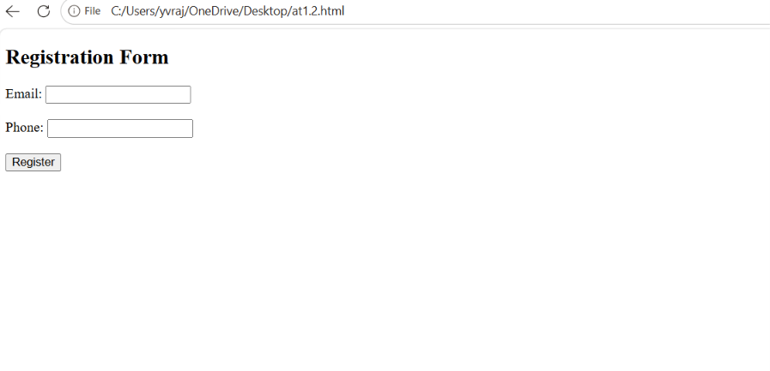
(a) Analyze the issues in the existing form validation mechanism.
- Invalid email formats are accepted.
- Phone numbers may contain letters or incorrect lengths.
- No real-time validation.
- Incorrect data can be submitted.
(b) Design input fields for email and phone number with appropriate HTML attributes.
- Used type="email" for email.
- Used required attribute.
- Phone number input is validated using JavaScript.
(c) Implement JavaScript validation using Regular Expressions for both email and phone number.
- Email Regex:
/^[^\s@]+@[^\s@]+\.[^\s@]+$/
- Phone Regex:
/^[0-9]{10}$/
(d) Develop a mechanism to display real-time error messages for invalid inputs.
- Displays "Invalid Email" for incorrect email format.
- Displays "Enter 10-digit Phone Number" for invalid phone numbers.
(e) Evaluate the validation system and suggest enhancements for better user experience and security.
- Prevents invalid data submission.
- Improves data accuracy.
- Further enhancements:
- Validate while typing using the input event.
- Add password strength validation.
- Sanitize inputs on the server side.
- Use HTTPS and server-side validation for better security.
Experiment 3: CSS Layout Debugging
Suppose that a webpage layout overlaps when the browser window is resized, affecting
usability.
Source Code:
<!DOCTYPE html>
<html>
<head>
<title>CSS Layout Debugging</title>
<style>
*{
margin:0;
padding:0;
box-sizing:border-box;
}
body{
font-family:Arial;
}
.container{
display:flex;
flex-wrap:wrap;
gap:10px;
padding:10px;
}
.box{
flex:1;
min-width:200px;
background:lightblue;
padding:20px;
border:2px solid blue;
text-align:center;
}
@media(max-width:768px){
.container{
flex-direction:column;
}
}
</style>
</head>
<body>
<h2 align="center">CSS Layout Debugging</h2>
<div class="container">
<div class="box">Header</div>
<div class="box">Content</div>
<div class="box">Sidebar</div>
</div>
</body>
</html>
Output:
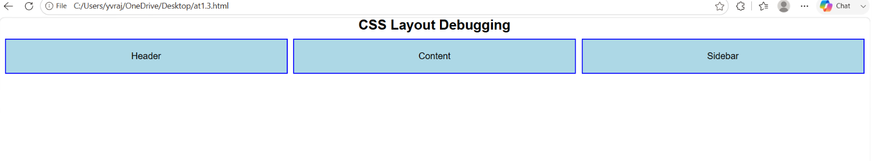
(a) Analyze the CSS properties responsible for layout overlapping issues.
- Fixed width and height values.
- Incorrect use of position: absolute.
- Missing responsive design.
- No flex-wrap or media queries.
- Excessive margins or padding.
(b) Examine the role of the CSS box model (margin, border, padding, content) in layout
design.
- Content: Main content area.
- Padding: Space inside the border.
- Border: Surrounds the padding and content.
- Margin: Space outside the border.
(c) Debug the layout using appropriate positioning techniques (relative, absolute, flex,
grid).
- Used Flexbox for responsive layout.
- Added flex-wrap: wrap to avoid overlap.
- Used media queries for smaller screens.
- Avoided unnecessary absolute positioning.
(d) Modify the CSS to ensure proper alignment and prevent overlapping during resizing.
- Added box-sizing: border-box.
- Used display: flex.
- Added gap for spacing.
- Used min-width and media queries for proper alignment.
(e) Evaluate the corrected layout and suggest best practices for maintaining consistency.
- Layout no longer overlaps when resized.
- Responsive on desktop, tablet, and mobile.
- Best practices:
  - Use Flexbox or CSS Grid.
  - Avoid fixed widths where possible.
  - Use responsive units (%, rem, vw).
  - Test layouts on different screen sizes.
  - Keep consistent spacing with margin, padding, and gap.

